EMS Science Fair
Judges Needed

Location: Esparto Middle School Contact: Erin Simons (Science Teacher)
Date: November 14 (Thursday) Text Interest: (951) 206- 3915
Time: 8am-12:00 pm
Description: It’s that time of year again! Science Fair! 6-8th grade students are implementing their knowledge of the scientific method in order to investigate more about the world around them.
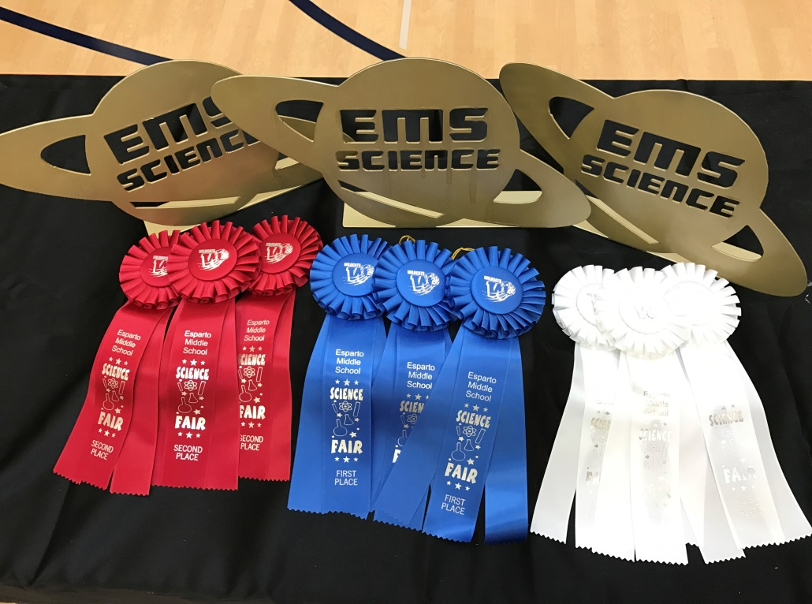
What We Need: We need 3-4 judges per grade level who have knowledge of science and the scientific method. We are looking for judges who are willing to listen to 2 minute presentations by our students regarding their scientific research and are willing to ask the kids tough questions.

What You Get: A great opportunity to get invested in a child’s life! Breakfast and Lunch Provided <3
Other Ways to Help: We are currently raising funds to help get our first place winners for each grade level to the California Academy of Science in San Francisco. Please consider donating $30.00 to help purchase a child’s ticket.

